FIT Group Project

Public Domain Statement

CC0 Universal Domain Dedication – Copyright

The person[s] who associated a work with this deed has dedicated the work to the public domain by waiving all of his or her rights to the work worldwide under copyright law, including all related and neighboring rights, to the extent allowed by law.

You can copy, modify, distribute and perform the work, even for commercial purposes, all without asking permission.

In no way are the patent or trademark rights of any person affected by CC0, nor are the rights that other persons may have in the work or in how the work is used, such as publicity or privacy rights.

Unless expressly stated otherwise, the person[s] who associated a work with this deed makes no warranties about the work, and disclaims liability for all uses of the work, to the fullest extent permitted by applicable law.

When using or citing the work, you should not imply endorsement by the author or the affirmer.

Note: Images are referenced to Design Dossier.

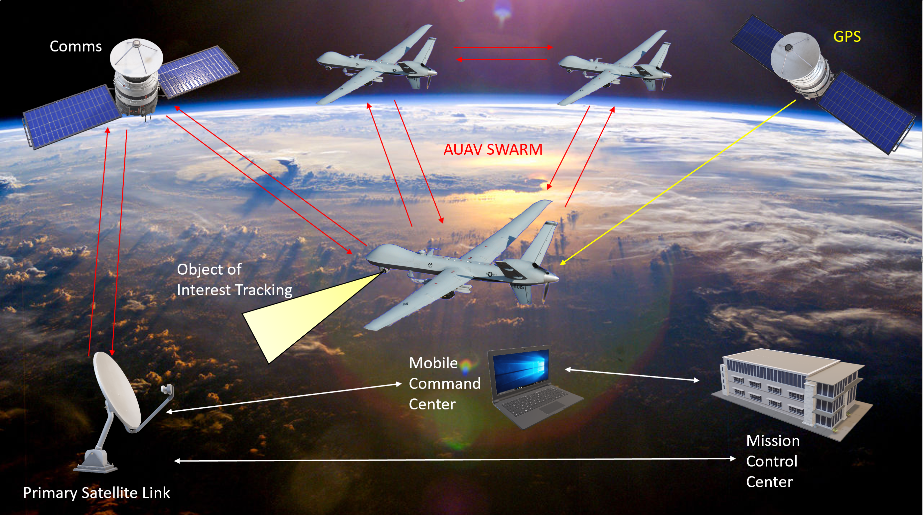

Figure *2c: Concept of Operations Diagram*

**Source of Information**

* <https://www.google.com/url?sa=i&url=https%3A%2F%2Fen.wikipedia.org%2Fwiki%2FGeneral_Atomics_MQ-9_Reaper&psig=AOvVaw0zKPtNjmO9Vb6I1vYCNsLf&ust=1597189126443000&source=images&cd=vfe&ved=0CAIQjRxqFwoTCOCm87TnkesCFQAAAAAdAAAAABAD>

“*This article contains material that originally came from the web article* [Unmanned Aerial Vehicles](https://www.webcitation.org/6CJpO2nC0?url=http://www.vectorsite.net/twuav.html) *by Greg Goebel, which exists in the public domain.”*

* Figured created by Aaron Huntoon, all images contained in the diagram were obtained online through the link mentioned above.

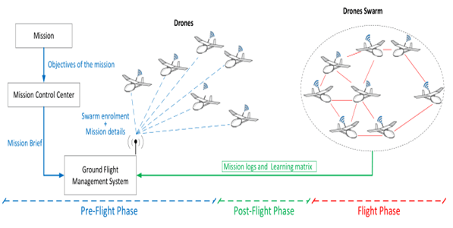

Figure *3c: AUAV SWARM mission coordination*

**Source of Information**

* [**https://www.google.com/imgres?imgurl=https%3A%2F%2Fwww.rfwireless-world.com%2Fimages%2FDrone-Swarm-System.jpg&imgrefurl=https%3A%2F%2Fwww.rfwireless-world.com%2FTerminology%2FHow-Drone-Swarm-System-Works.html&tbnid=JmXrBKvn78aIQM&vet=12ahUKEwjFl8Po6ZHrAhWMAlMKHRLbAZEQMygAegUIARCYAQ..i&docid=oU3MSXITWs5E2M&w=597&h=300&q=uav%20swarm%20graphic&ved=2ahUKEwjFl8Po6ZHrAhWMAlMKHRLbAZEQMygAegUIARCYAQ**](https://www.google.com/imgres?imgurl=https%3A%2F%2Fwww.rfwireless-world.com%2Fimages%2FDrone-Swarm-System.jpg&imgrefurl=https%3A%2F%2Fwww.rfwireless-world.com%2FTerminology%2FHow-Drone-Swarm-System-Works.html&tbnid=JmXrBKvn78aIQM&vet=12ahUKEwjFl8Po6ZHrAhWMAlMKHRLbAZEQMygAegUIARCYAQ..i&docid=oU3MSXITWs5E2M&w=597&h=300&q=uav%20swarm%20graphic&ved=2ahUKEwjFl8Po6ZHrAhWMAlMKHRLbAZEQMygAegUIARCYAQ)
* Figure/graphic obtained online through the link mentioned above.

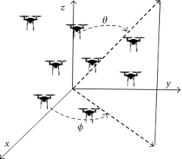

Figure *4g: AUAVs forming a 3D array for interferometry*

**Source of Information**

* <https://www.google.com/imgres?imgurl=https%3A%2F%2Fstatic-01.hindawi.com%2Farticles%2Fijap%2Fvolume-2016%2F2621862%2Ffigures%2F2621862.fig.001.svgz&imgrefurl=https%3A%2F%2Fwww.hindawi.com%2Fjournals%2Fijap%2F2016%2F2621862%2F&tbnid=1EutzRicj1bvTM&vet=12ahUKEwiXiKv76pHrAhUFB1MKHfKuDN4QMygAegUIARCiAQ..i&docid=4mXJ_XQ8-0yl6M&w=305&h=267&q=uav%20forming%20a%203d%20array&ved=2ahUKEwiXiKv76pHrAhUFB1MKHfKuDN4QMygAegUIARCiAQ>
* This is an open access article distributed under the [Creative Commons Attribution License](http://creativecommons.org/licenses/by/4.0/), which permits unrestricted use, distribution, and reproduction in any medium, provided the original work is properly cited.

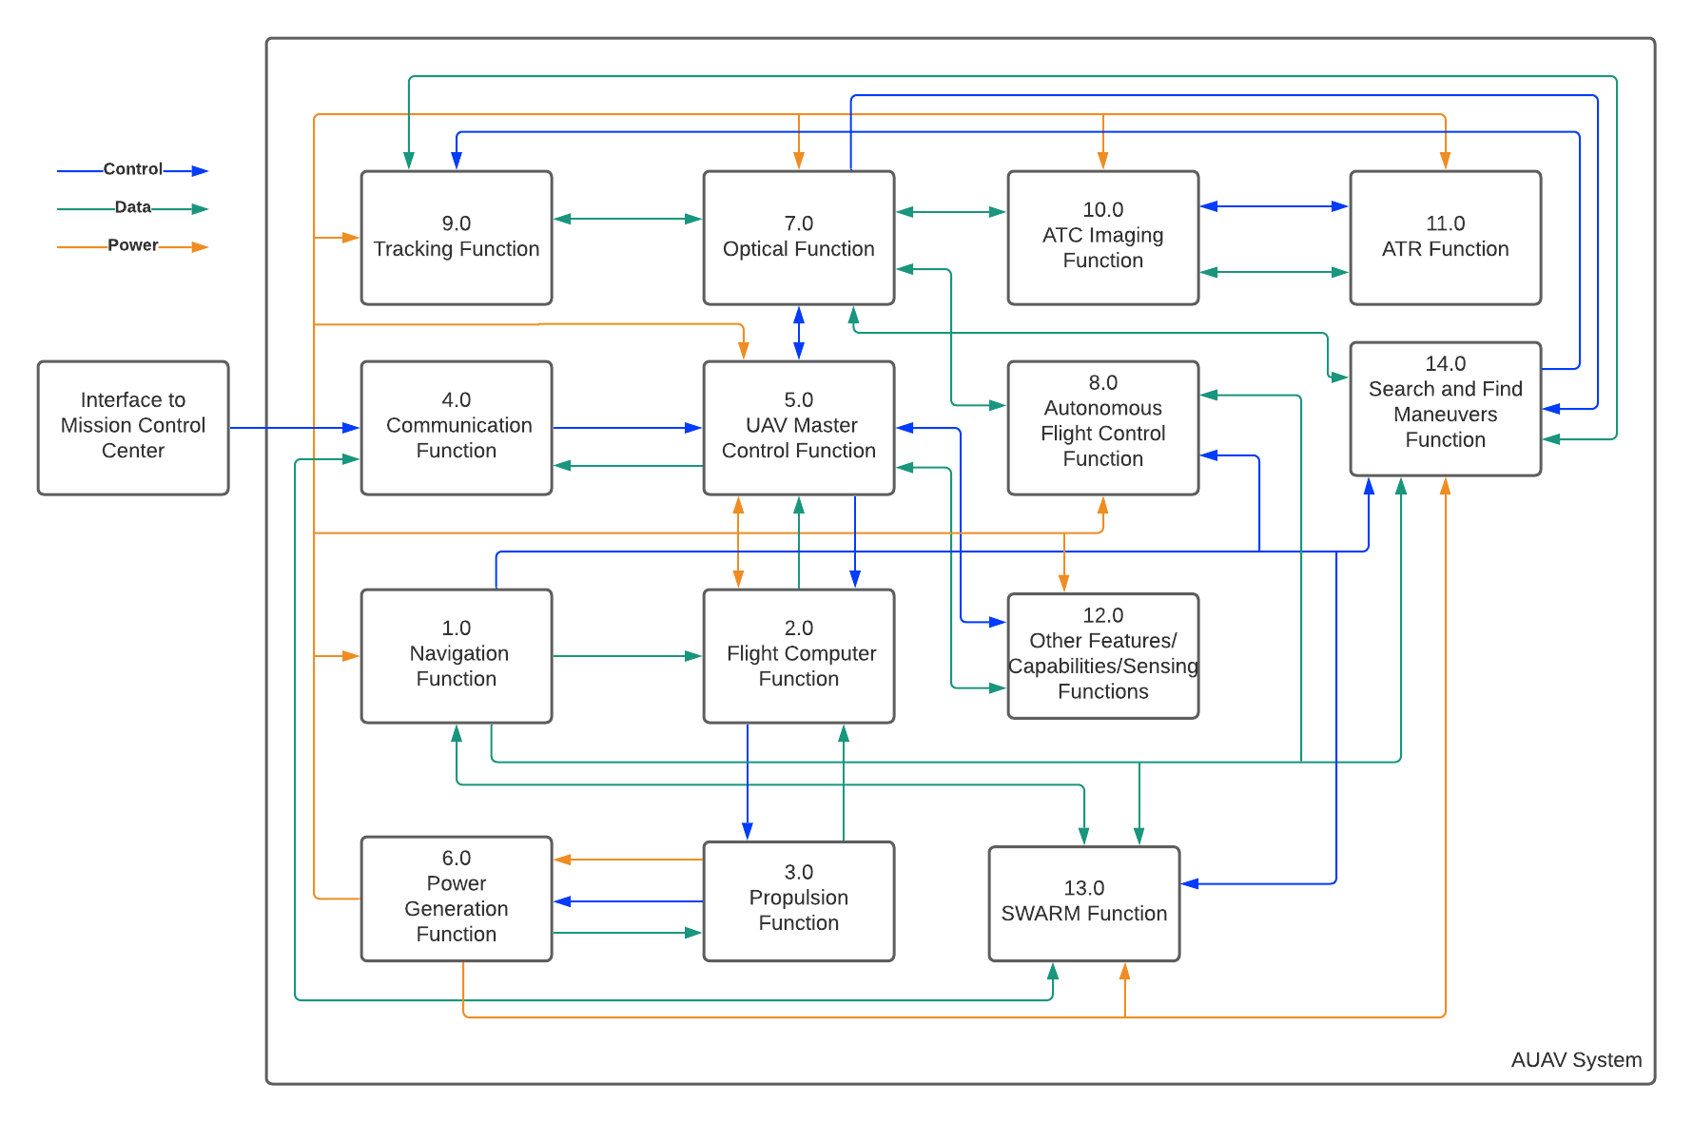

*Figure 6: High Level Subsystem Functional Diagram*

* Figure created by Linda Camacho, updated with functional block diagrams obtained by the Design Dossier Project Automatic Target Recognizer (ATR) U.S. Border Patrol Optical Sub-System Integration
* <https://onedrive.live.com/view.aspx?cid=99996a2d5edba56b&page=view&resid=99996A2D5EDBA56B!10475&parId=99996A2D5EDBA56B!10435&authkey=!APXONaclE8yUEKw&app=Word>

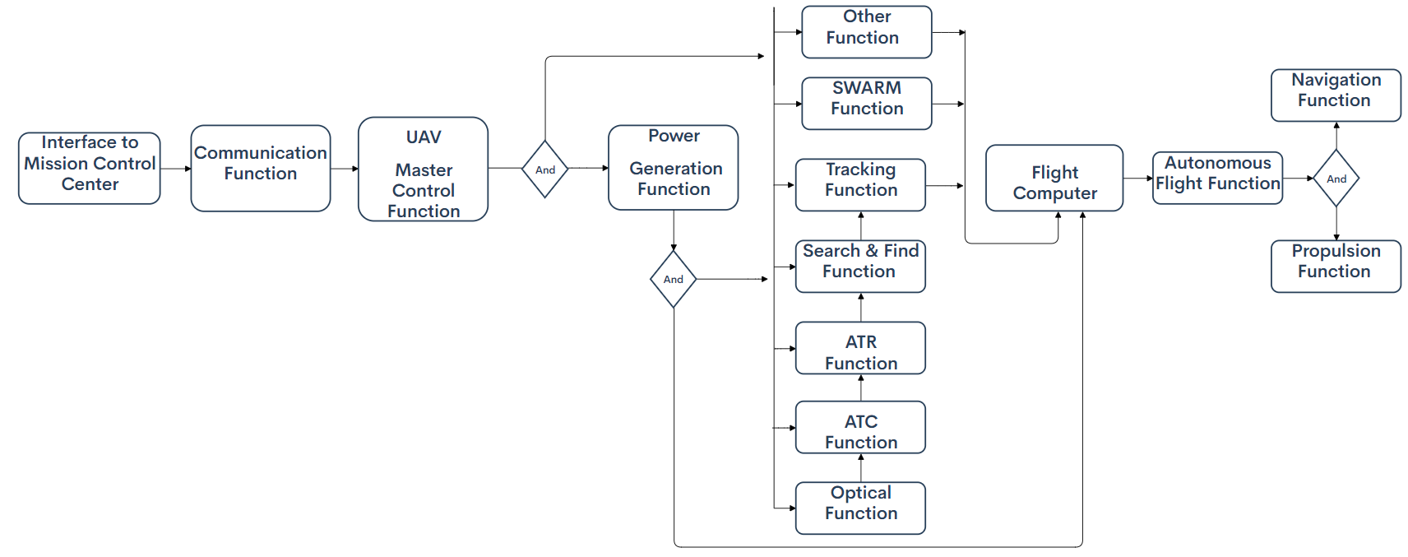

*Figure 10: System Flow Diagram*

Figure Created by Bralen Berry to update the FIT Designer Dossier.

*Figure 1: Quality Functional Deployment*

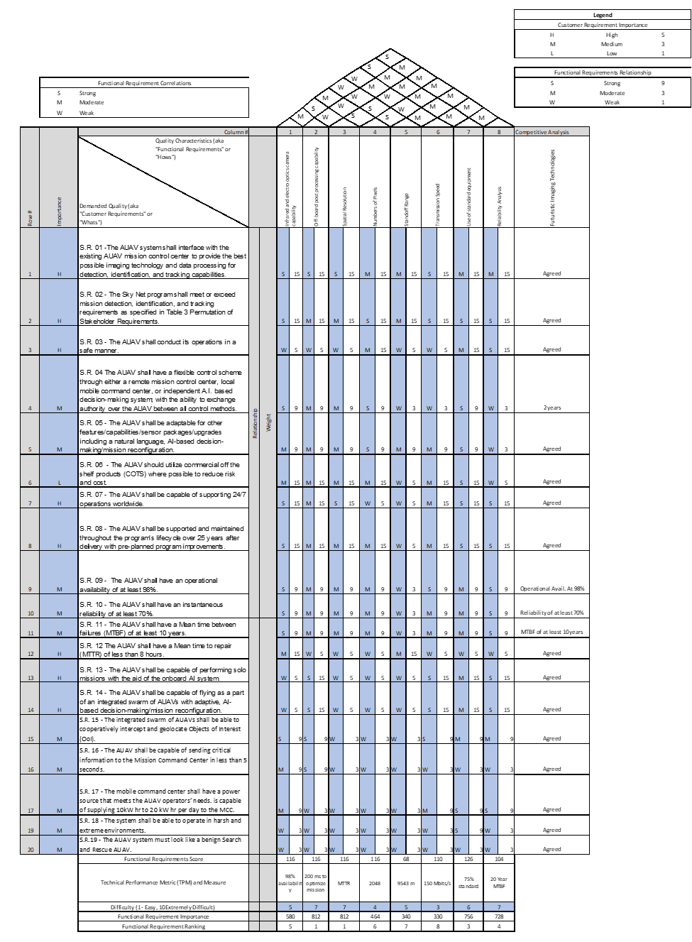  
Figure Updated by Bria Booth and Dylan Huss to update the FIT Designer Dossier.

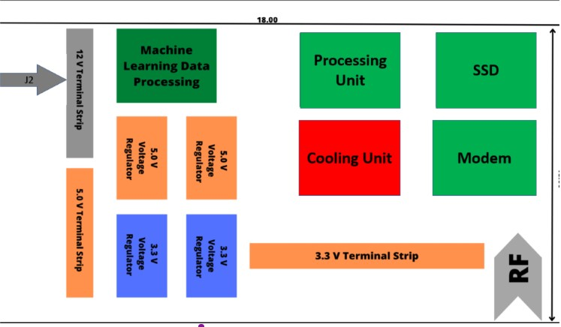

Figure Updated by Nisarg, Dhwanil, Mariana and Dylan. (AI – ICD block diagram)

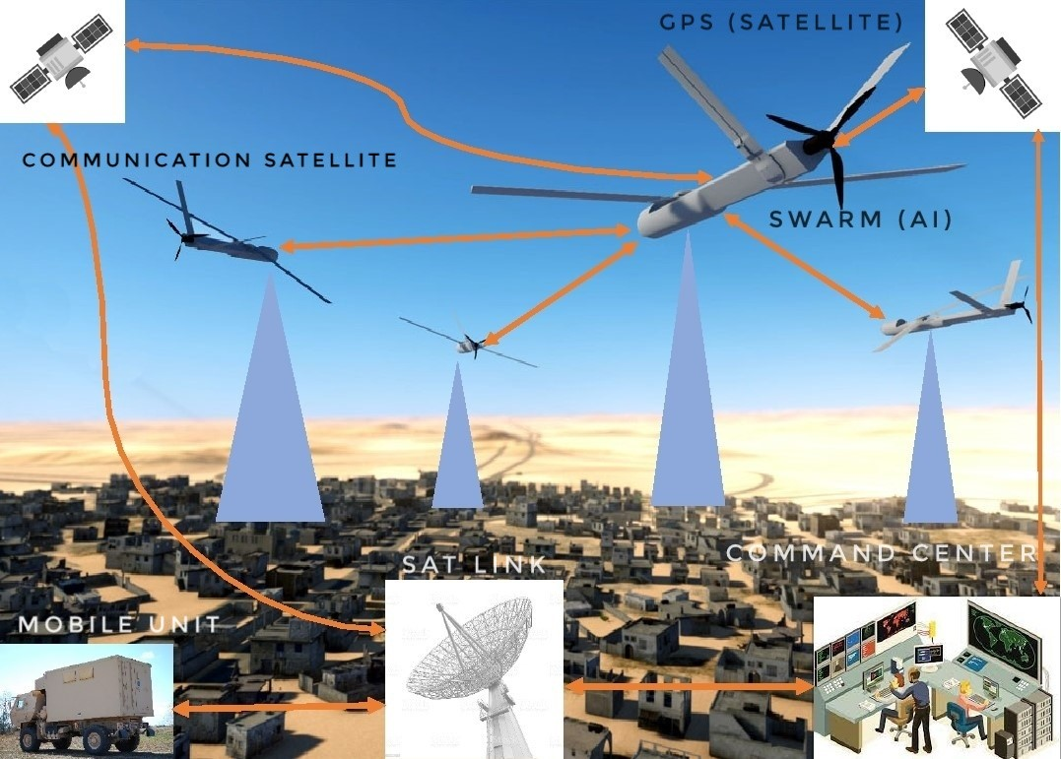

Figure Updated by Nisarg Shah and Dhwanil Desai to update the FIT Designer Dossier.

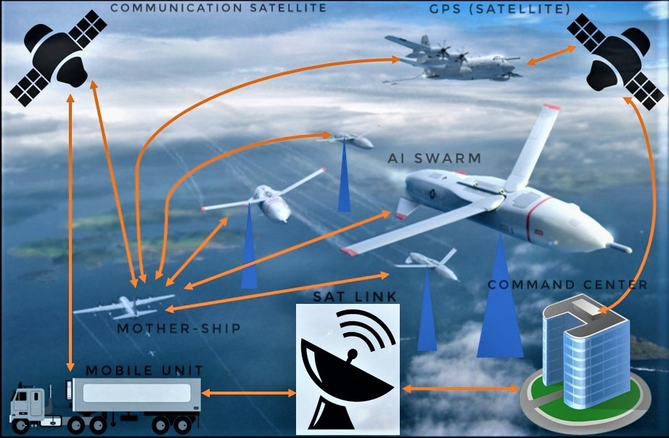

Figure Updated by Nisarg Shah and Dhwanil Desai to update the FIT Designer Dossier.

**Links For CONOPS Pictures:**

1.) <https://publicdomainvectors.org/en/free-clipart/Satellite-Dish-Icon/38135.html>

2.) <https://publicdomainvectors.org/en/free-clipart/Satellite-icon-vector-clip-art/19884.html>

3.) <https://publicdomainvectors.org/en/free-clipart/Vector-graphics-of-office-tower-block-with-grass/29841.html>

4.) <https://publicdomainvectors.org/en/free-clipart/Vector-image-of-mobile-refuel-container-truck/18706.html>

5.)<https://commons.wikimedia.org/w/index.php?search=military+drone+&title=Special:MediaSearch&go=Go&type=image>

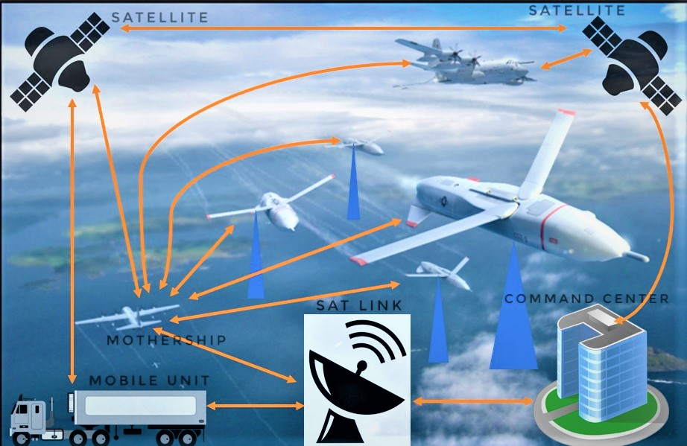

Figure Updated by Nisarg Shah and Dhwanil Desai to update the FIT Designer Dossier.

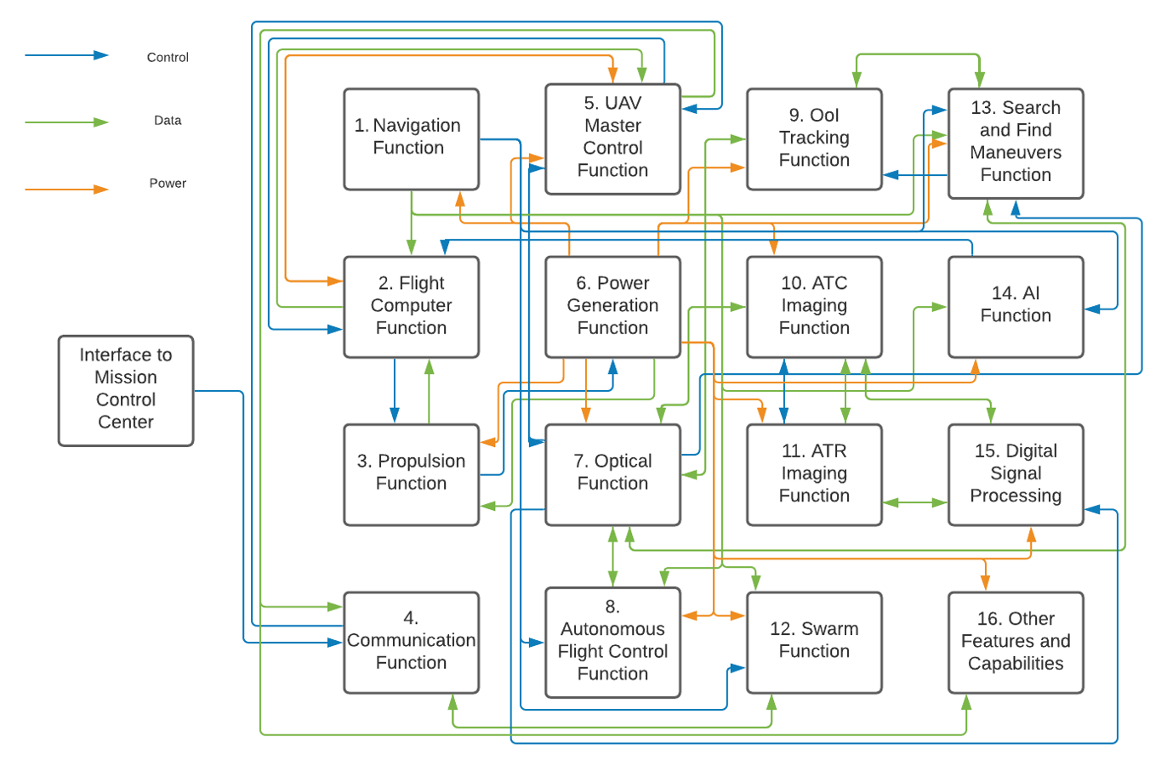

Figure Updated by Bria Booth using LucidChart to include DSP and AI Function.

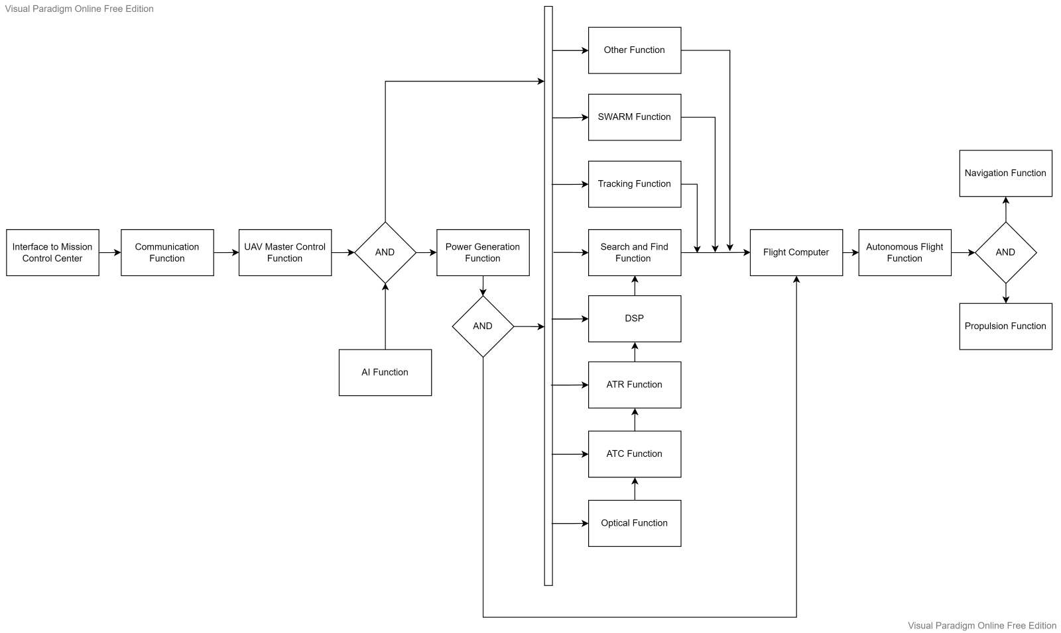

Figure Created and Updated by Dylan Huss using Visual Paradigm free online software to include DSP and AI Function.